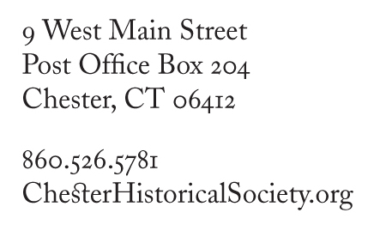­­

**Membership Form**

**2-for-1 Special**

**New Members Only**

**Join now and enjoy your next year Free!**

Chester Historical Society memberships (except Life Memberships) are paid annually. We ask all members, including Life Members,

to complete the personal info and their volunteer support interests.

**Please include on the membership roll for the membership year ending June 30th**

Name(s) _______________________________________________________________________________________________

Mailing Address ______________________________________________________________________________________

__________________________________________________________________________________________________________

E-mail ___________________________________________________________ Phone ____________________________

**Please Note: Your e-mail address is important to us. It’s become a primary way to inform our members of Society activities and includes the Robbie Collomore Music Series. We do not share your email addresses with others.**

**Membership**

**Level**

I would like to be a Society member for the next year as indicated

* Student ($15)
* Individual ($20)
* Household ($35)
* Benefactor ($100)
* Sponsor / Corporate ($250)
* Life ($1,000) One-time payment to enroll one or two individuals in the same household as lifetime members.
* Please accept my additional donation for $ ___________

**Volunteer**

**Support**

I have interest in working with others in the following areas

**All dues and donations are fully tax-deductible.**

**Make checks payable to *Chester Historical Society***

**Mail to: CHS, PO Box 204, Chester, CT 06412**

Please consider your check your receipt.

Thank you for your support.

your

* Refreshments for events
* Fundraiser Committee
* Mailings preparation
* Articles for newsletter
* Publications Committee
* Sunday Market Table
* Collections / Archives
* Greeting visitors at Museum
* Oral history interviews
* Exhibit Planning
* Program Planning
* Museum Maintenance